RouteSAV

Xande Koh Yong En, Nicholas Sng Ray Shiang, Kenneth Wang Yong Qi, Muhammad Fiqri Adam Bin , Goh Geok Ling  
*Infocomm Technology Cluster*  
*Singapore Institute of Technology*Singapore  
2203203@sit.singaporetech.edu.sg , 2203197@sit.singaporetech.edu.sg , 2203193@sit.singaporetech.edu.sg , 2202878@sit.singaporetech.edu.sg , 2202614@sit.singaporetech.edu.sg

***Abstract*—This report introduces RouteSAV, a solution designed to help revolutionise the operation of tourist bus companies in travelling to and fro the airport. As we strive to become a greener city, our solution does ensure minimal fuel consumption for different kinds of vehicles. The main objective of RouteSAV would aid drivers in providing a seamless, cost-effective, and efficient tours bus journey, to or from Changi Airport Terminal 3, to or from selected hotels. With the help of cutting-edge algorithms, RouteSAV will help to optimise the travel route by analysing real-time data and leveraging advanced optimization technology. This algorithm would include fuel consumption, road conditions, and ERP fees while ensuring a smooth and enjoyable journey for all tourists.**

**Keywords - Data Structure, Dijkstra’s Algorithm, Route Optimisation**

# Introduction

Imagine a future where every tourist bus journey from Changi Airport to hotels in Singapore is seamless, cost-effective, and efficient. RouteSAV, an innovative algorithmic solution, aims to realise this vision by revolutionising tourist bus companies' operations. Our goal is simple yet powerful, which is to minimise operating costs while providing efficient transportation that delights tourists and bus operators.

Singapore's tourist travel bus business has been a crucial component of the tourism industry [1]. It provides efficient transport services to ferry tourists from Changi Airport to their respective hotels. As Singapore has emerged as a popular global tourist destination, reliable and cost-effective transportation has become increasingly critical.

At RouteSAV, we understand the challenges faced by tourist bus companies in managing expenses such as fuel consumption, electronic road pricing (ERP) fees, and overall operating costs. That's why we have developed a cutting-edge algorithm that optimises the travel route from Changi Airport Terminal 3 to a selected hotel in Singapore. By analysing real-time data and leveraging advanced optimization techniques, we can reduce fuel consumption, navigate around congested areas, and minimise ERP fees, all while ensuring a smooth and enjoyable journey for tourists.

# Literature Review

To develop RouteSAV, we conducted research to explore existing knowledge and approaches related to optimising travel routes, minimising operating costs, and leveraging existing tools and solutions. The following are some of our findings.

**Mapping and Routing Services**

Mapping and routing services play a crucial role in providing directions and optimising travel routes. Services such as Google Maps, Map Quest and OpenStreetMap offer comprehensive mapping functionalities and route calculation capabilities. These services utilise algorithms that consider factors like traffic conditions, transportation modes, and real-time updates to provide accurate and efficient routing information [2].

**Fuel Consumption**

Studies have shown that optimising travel routes can significantly reduce fuel consumption by 20% [3]. Factors such as driving speed, route selection, and traffic congestion directly impact fuel efficiency. Eco-routing strategies, which consider fuel consumption as a parameter in route calculation, have gained attention in the field of transportation optimization. These strategies aim to minimise fuel usage by identifying routes that are not only shorter but also more fuel-efficient.

**Electronic Road Pricing (ERP) System**

Electronic road pricing systems, charge fees based on road usage and congestion [4]. Minimising ERP fees can contribute to cost reduction for the tourist bus company. Existing research has proposed algorithms and methods that take ERP charges into account when optimising travel routes. These approaches consider factors such as toll rates, time-of-day pricing, and alternative routes to minimise ERP costs.

**Operational Cost Minimization**

Efficient operational management plays a crucial role in cost minimization for transportation as there are a few factors to consider when planning and trying to find a route that is most cost effective and efficient for both the driver as well as the commuters.

## Existing Solutions

In this following section, we will explore two popular route-finding applications that have been developed to assist users in identifying the most efficient and convenient route for their journeys. Both Waze and Google Maps are existing tools and solutions that have been developed and widely used.

**Google Maps**

Google Maps is a web mapping platform by Google. It offers route planning, real-time traffic updates, and street maps. To assist users in navigating effectively, Google Maps offers detailed instructions, estimated travel times, and real-time traffic information [5].

Emerging as a ubiquitous tool that has revolutionised how we navigate the world. Its continuous evolution provides various features to users such as street view and satellite view. There are various algorithms used to help find the shortest path and locate one’s position, and geocoding. Geocoding is another key aspect that allows users to input addresses or place names and obtain precise coordinates for those locations, thus facilitating seamless integration with other applications and services [6].

There is however a possibility that the maps on Google may not always be up-to-date with regard to route and information since a significant amount of the information on Google Maps is based on data that is generated by users, as well as data that has been provided by other sources [7].

In addition to this, there has been research conducted on whether the route provided by Google Maps is the most fuel-efficient route, which is something that Google Maps is still working on in order to improve it [8].

**Waze**

Waze is a mobile navigation application that provides real-time traffic information to users [9]. To offer drivers the best route, it uses GPS and crowdsourcing data to get live updates on traffic conditions, incidents, and road hazards [10].

Although Waze was acquired by Google in 2013 [11] and both offer navigation services, it has taken a different approach to navigation and mapping services as compared to google maps.

One of the unique selling points of Waze is that it relies heavily on Community-Generated feedback. Waze users(wazers) will be encouraged to actively contribute to the app by reporting the road conditions, accidents, hazards, and police presence in real-time [11]. This information is then shared with other wazers to help them predict what their journey duration is going to be like and the road conditions.

To encourage users to report what they see, Waze gamified the driving experience by rewarding users with points, ranks, and achievements. This gamification not only encourages wazers to report but also adds an element of fun to users during their journey to their destination [12].

To ensure that wazers always get the most optimum route to their destination, Waze has implemented dynamic routing into their navigation system. Wazers routes will be automatically rerouted to avoid longer driving time on the road. A few key pointers that are taken into consideration that can cause delays are things like traffic jams or accidents. All these data are procured in real time [13]. Avoiding all these obstacles and factoring in the time taken to avoid or go through these obstacles, is what makes Waze different from google maps.

**OneMap**

OneMap is the official map developed and maintained by the Singapore Land Authority (LTA). It is often regarded as the most complete and current source of geographic data for the entire nation. OneMap's data includes a wide range of crucial specifics, including precise mapping of streets, buildings, landmarks, parks, and other vital geographic features [14].

OneMap includes a wealth of useful day-to-day information and services that have been provided by numerous government organisations in addition to its significance as a cartographic resource. This includes information about amenities, public transit, healthcare services, educational institutions, and more. Through OneMap's user-friendly interface, citizens can get access to these important services and data.

OneMap does not, however, identify which of the routes it has offered as the best path, as shown in Figure 1. Additionally, it is not clear if the route calculation takes incidents and tolls into account.

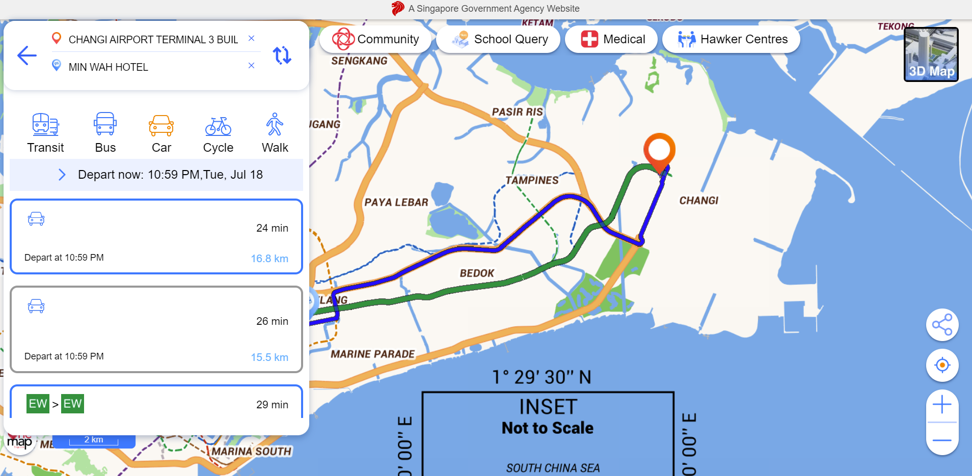

1. OneMap Interface

# Solution Designed

## Assumptions Made

In the following section, we will be detailing the assumptions we made at the time of making the program in order to justify our conclusions.

**Vehicle type**

We assumed that the vehicle type is a Scania Touring Coach with specifications of 18.2 litres per 100km [15]. These specifications will be used as the basis for any calculation that is made.

**Max Speed for buses in Singapore**

To ensure that our routes are in accordance with the law of Singapore, we take into account that buses can run at 60 km/h on expressways and 50 km/h on normal roads [16].

**Size of Map Nodes**

In this project, the nodes that we have extracted are only part of Singapore from Changi to the center of Singapore. This ensures that our program is able to run smoothly on any device as well as the nodes that we have taken ensure that the most accurate route is calculated.

## System Diagram

In the following section, we will be presenting our system design which would include the algorithm, packages, and data structure used as well as the integration and infrastructure of our proposed solution.

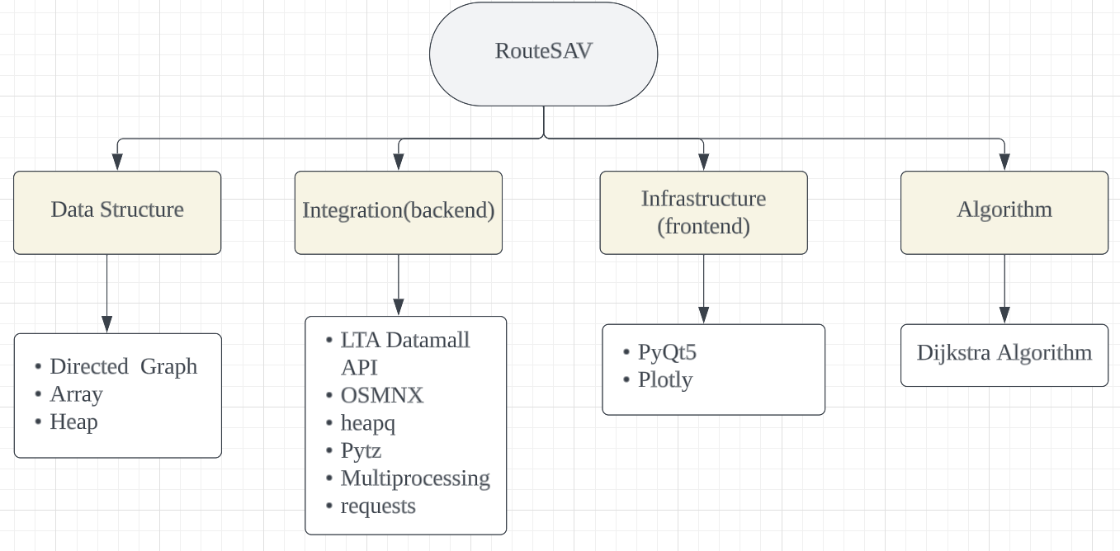

1. RouteSAV System Design

RouteSAV uses data structures like Heap, Directed Graphs, and Arrays are used in programs to efficiently organise and manipulate data. Heap is used for priority queues and sorting used during our program. A directedGraph represents relationships and aids pathfinding algorithms.Arrays store elements with fast access through indices and underpin various data structures.

RouteSAV has been significantly enhanced by integrating multiple tools and libraries, such as LTA Datamall API, OSMnx, Heapq, Pytz, Multiprocessing, and Requests. The LTA Datamall API would provide real-time data on public transportation and traffic conditions, while OSMnx would improve mapping accuracy and geospatial visualisation. Heapq could aid in efficient navigation and pathfinding, and Pytz would handle time zone conversions accurately. Multiprocessing would boost performance, and Requests would facilitate seamless communication with external APIs and services. These integrations ensure RouteSAV remains a comprehensive and dynamic mapping platform.

With PyQT5 and Plotly, this has allowed us to build a desktop application with a graphical user interface for the user to put their inputs.The PyQt5 library, a collection of Python bindings for the Qt application framework, is imported into the code sample along with its necessary modules and classes. It comprises QtWebEngineWidgets for integrating web material, QtWidgets for building GUI elements, QtCore for fundamental functions, and QtGui for graphical elements. To show text or photos, QLabel is utilised, while QComboBox generates drop-down lists for item selection. While Plotly is a popular Python library that allows you to create interactive visualisations, including maps. Plotly provides various functionalities and chart types to build interactive and visually appealing data visualisation.

With the help of Dijkstra's algorithm being used to find the shortest path in a weighted graph with non-negative edge weights in RouteSAV. Starting from a specified source vertex and efficiently calculates the shortest distance to all other vertices. The algorithm uses a priority queue and repeatedly explores neighbouring vertices, updating their distances if a shorter path is found. It is widely employed in various applications, such as GPS navigation and network routing, but is suitable only for graphs with non-negative weights. For graphs with negative weights, other algorithms like Bellman-Ford are more appropriate.

# Solution Implementation

Our implemented solution is RouteSAV, where its primary objective is to provide a comprehensive and cost-effective solution that optimises tourist bus journeys from Changi Airport Terminal 3 to hotels in Singapore. The choice of hotels is made based on a number of criteria, such as the lack of shuttle services offered by the hotel or Changi Airport, the ease of being close to the Mass Rapid Transit (MRT), the proximity of the hotels to one another, and the absence of hotels that provide free transportation services. The chosen hotels are Ibis Budget Singapore Pearl, Amrise Hotel, and Min Wah Hotel.

RouteSAV aims to achieve this with the help of advanced algorithms and real-time data analysis to calculate the most efficient routes while considering various factors such as petrol cost, traffic conditions, distance, and passenger capacity. RouteSAV uses the Dijkstra algorithm coupled with other existing technologies and solutions, which allow us to find the shortest path and the minimum distance to various destinations. By applying this algorithm, we can determine the best routes for tourist buses, ensuring efficient and timely transportation.

In addition to the Dijkstra algorithm, we intend to integrate the Land Transport Authority (LTA)’s Application Programming Interface (API) by using their data such as ERP charges, traffic congestion, and potential obstacles encountered along the way. Using this data, we will be designing an algorithm that would meticulously plan out the routes using our algorithmic solution. Coming up with the best available path and minimising cost for bus drivers enhancing the overall travel experience for tourists.

What makes us distinct from Google Maps and Waze would be the ability to provide and consider the ERP charges incurred based on the time. Hence, RouteSAV aims to optimise each tourist bus trip to its fullest potential, bringing benefits to bus operators by reducing operating expenses, and simultaneously, picking up as many tourists to their destination.

## Dataset Used

RouteSav used multiple data sources and dependencies to ensure efficient and effective route planning. One of the key data sources we rely on is OpenStreetMap (OSM), which provides comprehensive road network data. We utilised the Osmnx library to retrieve this data and represent it as a graph, facilitating streamlined route calculations.

For real-time traffic updates, we integrated the LTA Datamall API, which is made available by the Land Transport Authority. This API offers specific endpoints for accessing traffic incidents data and ERP rates. By utilising the Traffic incidents endpoint, RouteSav is able to obtain crucial information regarding road blockages and disruptions. To optimise routes effectively, our application processes this data to identify the nearest node in the OSM graph for each incident, enabling informed decision-making.

In addition to traffic incidents, we also utilise the ERP Rates endpoint to retrieve charges associated with passing through designated roads such as PIE or ECP. This information plays a vital role in accurately calculating the cost of ERP charges along a given route. By factoring in these expenses, RouteSav ensures that users receive optimal routes that not only consider travel time but also minimise toll costs.

## Data Preprocessing

**OSM Dataset**

The dataset utilised in this project is derived from OSMnx, which is built upon the comprehensive OpenStreetMap database. It focuses on a specific area in Singapore, encompassing noteworthy locations such as Singapore Changi Airport T3 and three hotels: Ibis budget Singapore Pearl, Min Wah Hotel, and Amrise Hotel. The dataset includes the extracted nodes representing these locations, as well as the entire network of possible routes connecting Changi Airport T3 with the earlier mentioned hotels.

**Graph**

After creating the graph from the OpenStreetMap (OSM), we utilised spatial indexing and geometric operations to identify and remove unwanted nodes that lie outside the specified polygon. First, a spatial index called an R-tree will be created for the graph nodes to enable efficient spatial queries. The nodes are then converted into a GeoDataFrame which is a tabular data structure with geometric information.

By performing a geometric operation known as “intersection” between the GeoDataframe and the polygon representing the bounding box, our Create_Graph function identifies which node geometries intersect with the polygon, indicating that they lie within the specified area. The intersection operation returns subsets of nodes that are inside the polygon, while the remaining nodes that lie outside are removed from the graph presentation. Additionally, any isolated nodes that are connected to the edges in the graph are also removed.

**ERP**

From the LTA Datamall API, we extract ERP data. We hardcoded their corresponding Zone IDs to handle certain ERP locations along PIE and ECP since these roads are viable options for our presumptive route. In order to meet the needs of our project, we identify the type of vehicle as a "big bus." Using the datetime library, we capture the current date and time. These elements, along with the zone ID and vehicle type, are essential in computing ERP fees. We incorporate these conditions to check against the ERP data and ascertain whether there are any applicable charges at the exact moment the program is executed. If ERP charges are found to be relevant based on the conditions, we include them as a contributing factor in our route calculation, aiding in the selection of the optimal route.

**Traffic Incidents**

We utilised LTA Datamall API to obtain live updates on traffic incidents, encompassing incidents like accidents, road works, vehicle breakdowns, obstacles, and more. However, we deliberately concentrate on particular incident categories for our project's route computation, particularly vehicle breakdowns, accidents, roadblocks, and heavy traffic. However, we deliberately concentrate on particular incident categories for our project's route computation, particularly vehicle breakdowns, accidents, roadblocks, and high traffic. Roadworks aren't included in our list because they often only affect a single lane or a small portion of the road, having little bearing on the calculation of the entire route. We guarantee a more precise and effective route planning by focusing on accidents with significant significance.

One challenge we face is that the coordinates provided by LTA may not precisely align with the node coordinates in our graph data. To fix this, we use the OSMnx nearest node function, which locates the closest node on our graph data for the location of each occurrence. By ensuring that the incidents are properly incorporated into our route calculating process, we can plan trips that are more trustworthy and efficient.

## Data Analysis

One of the key tasks is the fetching of map data. We were able to do this by retrieving map data from OpenStreetMap based on certain coordinates using the OSMX library. Directed graph is one of the important data structures used in this project due to its clear representation of one-way relationships, making it efficient to find valid paths from starting to target node. The data retrieved from the library was then processed and transformed into a graph representation of the road network, which formed the foundation for further analysis. The data is processed and converted into a graph representation of the road network, which served as the foundation of our analysis. It also facilitated route calculations by providing a well-defined structure for traversing and analysing the road network. The calculated paths are kept in lists, with each path being represented by a list of node IDs. We may manipulate and process the path data using the list, enabling calculations for metrics such as total distance.

In addition to directed graph and list data structure, dictionaries are also used to store ERP node IDs and their corresponding rates in the ‘ERP_NODES’ dictionary, which allows efficient retrieval of ERP rates based on the node ID during the calculation of total costs.

We use Dijkstra’s algorithm to determine the shortest path between the starting and end node. To find the best path, the algorithm traverses the graph and considers factors such as edge, length, speed limits, ERP charges, and incident nodes. The use of Dijkstra’s algorithm allowed for efficient path calculations and ensured that the generated path were based on accurate and up-to-date road network information.

Another significant factor in our analysis is toll avoidance. We offered users the choice to avoid toll roads, and our algorithm took this preference into account when the determining the best path. Our algorithm decides whether to omit toll charges from the path computation, allowing users to select their preferred route to save our customers travel costs. It did this by determining whether the neighbour node is an ERP node and whether to avoid it if the avoid toll option is selected.

Real-time traffic incident data was also taken into consideration in our analysis. We obtain this data through an API, process it, and then locate the incident nodes in the graph. Our algorithm will avoid congested or blocked areas by factoring in these incident nodes when calculating the path. By giving customers alternate routes based on the flow of traffic, this enhances the entire travel experience.

Numerous metrics, including the distance and time required to go from the start node to the end node, are also calculated in addition to the shortest path, toll avoidance, and traffic incidents. By adding the lengths of the graph's edges, the 'calculate_total_distance' function calculates the overall distance of a particular path. Users were given a sense of the whole distance they would have to go thanks to this.

The ‘calculate_cumulative_time’ function also estimates the total time needed to traverse along a path. It takes into account variables including edge length, speed limits, traffic conditions and incident nodes passed to provide users with an estimate of the overall time needed for the journey, enabling users to plan their trip more effectively.

Cost of fuel consumption is another important metric we took into consideration. The ‘calculate_fuel_consumption’ function makes an estimate of the fuel consumption for a specified distance. To determine the amount of fuel burned along the route, we used a predetermined fuel consumption rate per kilometre that was unique to the type of "big bus.". Users may plan and budget the fuel expenses with the help of fuel cost estimation.

We factored in total fuel cost and ERP charges when determining the trip’s overall cost. Using the ‘erp_rate’ function, the ‘calculate_total_cost’ function finds the ERP zone IDs that are in the computed route and utilises them to calculate the rates for each zone. Users can get a more accurate estimate of the total trip cost by including in ERP charges.

Finally, the route is optimised by comparing two alternative routes and selecting the best route based on criteria such as cumulative time, total distance, total cost, and fuel consumption. The optimal route is determined by comparing these criteria and swapping the routes if the alternative route performed better. This allows users to select the most suitable route based on their preferences and priorities.

To visualise the calculated route, the plotly library is used to plot the nodes and path on the map. This visual representation of the routes and their locations provided users with a clear understanding of the suggested paths and facilitated their decision-making process.

# Results and Insights

## Expected Result

The time and date mentioned for obtaining and analysing the expected results for this report are based on the current information generated as of 20 July 2023, as of 1725. There are certain circumstances that may change beyond our control, which could affect the accuracy or timeliness of the results. We make every effort to ensure both data are reliable when performing the analysis, but we cannot guarantee that unforeseen events or factors will not impact the final outcome. Hence, the result you get when you run our program will differ.

1. Changi Airport Terminal 3 to Ibis Budget Singapore Pearl

|  |  |  |  |  |
| --- | --- | --- | --- | --- |
| Route | Time Taken | Distance Taken | Cost | Fuel |
| Optimal Route | 25 min | 18.59 km | $0 | 3.38 litres |
| Alternate Route | 26 min | 18.02 km | $0 | 3.28 litres |

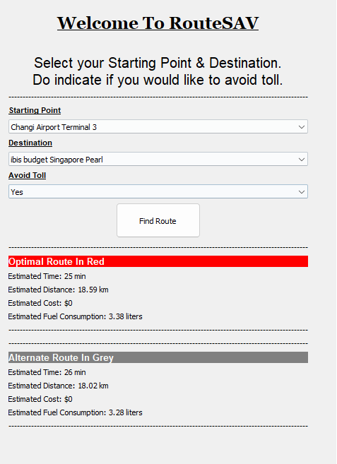

###### RouteSAV Result for Table I.

1. Changi Airport Terminal 3 to Amrise Hotel

|  |  |  |  |  |
| --- | --- | --- | --- | --- |
| Route | Time Taken | Distance Taken | Cost | Fuel |
| Optimal Route | 25 min | 18.50km | $0 | 3.37 litres |
| Alternate Route | 26 min | 18.27km | $0 | 3.33 litres |

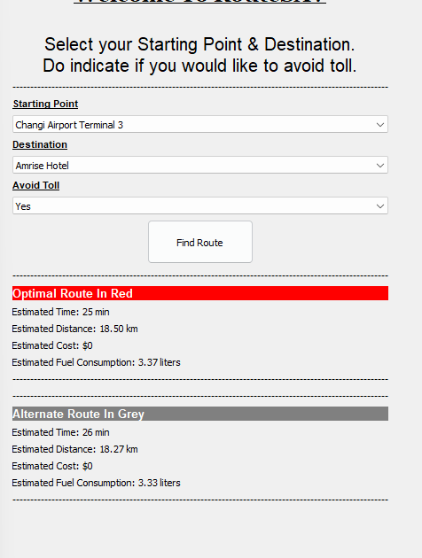

###### RouteSAV Result for Table II.

1. Changi Airport Terminal 3 to Min Wah Hotel

|  |  |  |  |  |
| --- | --- | --- | --- | --- |
| Route | Time Taken | Distance Taken | Cost | Fuel |
| Optimal Route | 25 min | 17.61km | $0 | 3.21 litres |
| Alternate Route | 26 min | 18.79km | $0 | 3.42 litres |

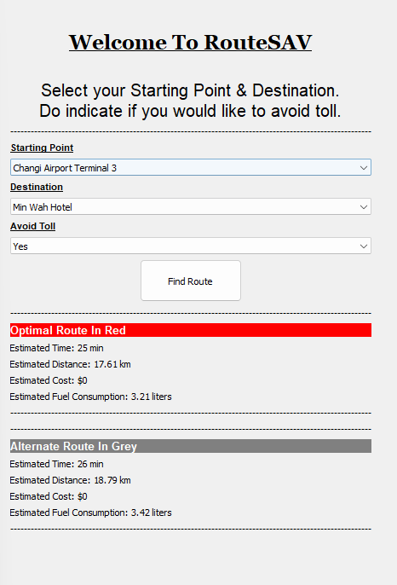

###### RouteSAV Result for Table III.

## B. Error Message

The program has been designed to prevent errors and lags by displaying an error message in an event when the source and destination input is the same. there will be an error message.

However, with the error message shown in Figure 6 being prompted, users are still able to make new selections away from the previously chosen location.

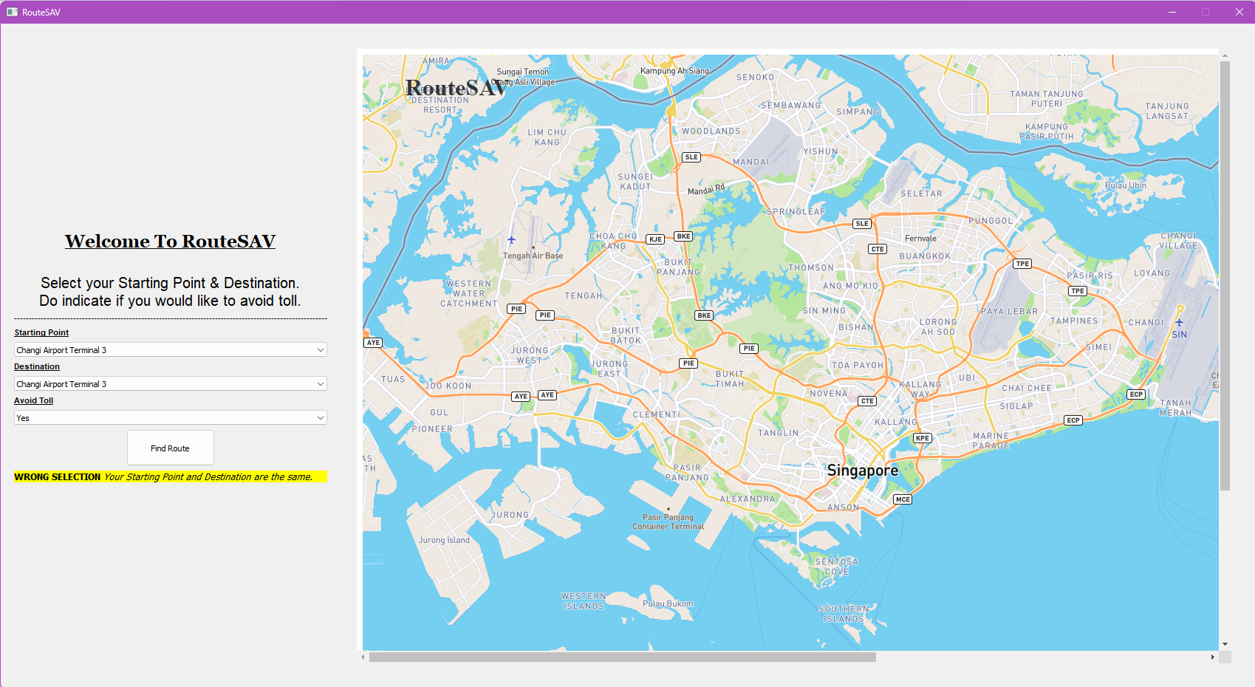

###### RouteSAV Error Message

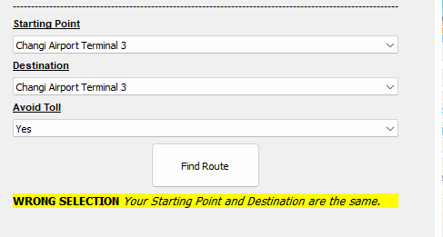

###### RouteSAV Error Message (Zoomed In)

## C. Comparison with other solutions

In order to demonstrate the efficiency and accuracy of our solution, a thorough comparison will be conducted. During this test, we will evaluate the route predictions, the computational speed, as well as the user satisfaction, highlighting its advantages while comparing it with existing alternatives. Do note that for Waze, it only allows user to plan trips hence only the timing with no overview of route or distance will be provided as its Waze application limitation.

1. Changi Airport Terminal 3 to Ibis Budget Singapore Pearl

|  |  |  |  |
| --- | --- | --- | --- |
| Time Taken | Distance Taken | Cost | Fuel |
| Google Maps | | | |
| 22 mins | 17.1 km | - | - |
| RouteSav | | | |
| 25 mins | 17.58 km | $0.0 | 3.2 litres |
| Waze | | | |
| 21 mins | - | - | - |

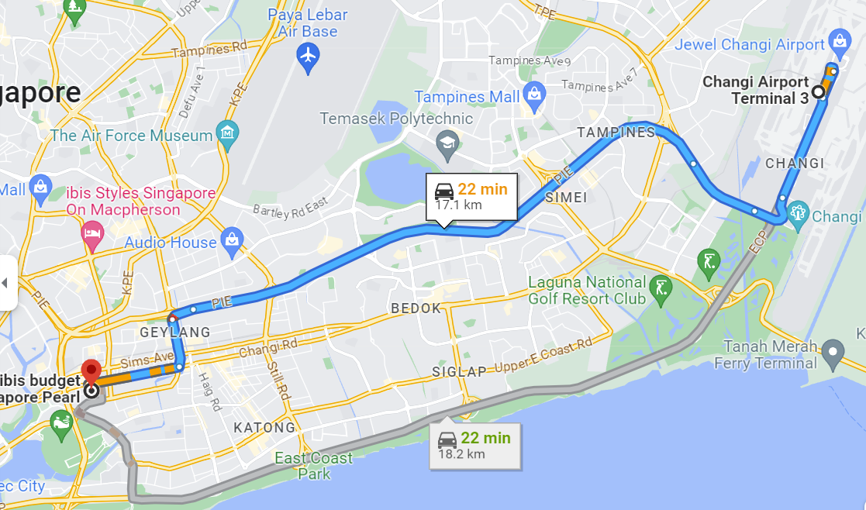

###### Google Maps Result for Table IV.

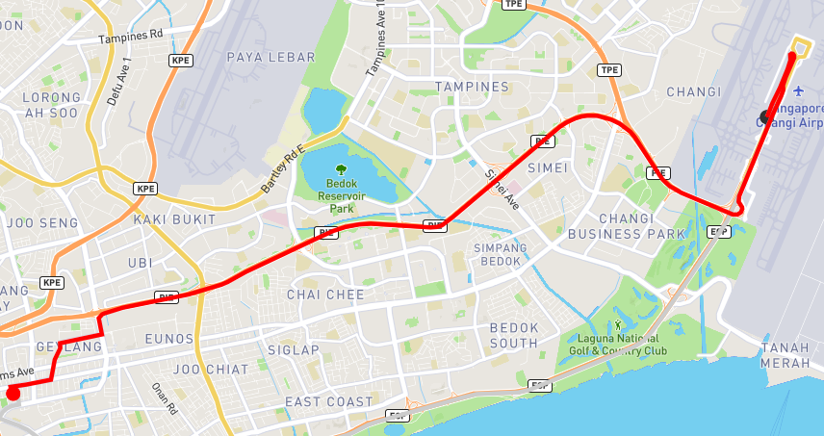

###### RouteSAV Result for Table IV.

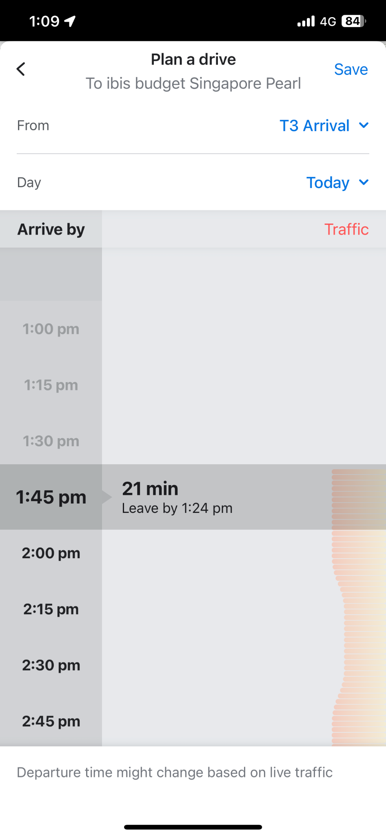

###### Waze Result for Table IV.

1. Changi Airport Terminal 3 to Min Wah Hotel

|  |  |  |  |
| --- | --- | --- | --- |
| Time Taken | Distance Taken | Cost | Fuel |
| Google Maps | | | |
| 20 mins | 16.8 km | - | - |
| RouteSav | | | |
| 24 mins | 17.7 km | $0.0 | 3.2 litres |
| Waze | | | |
| 20 mins | - | - | - |

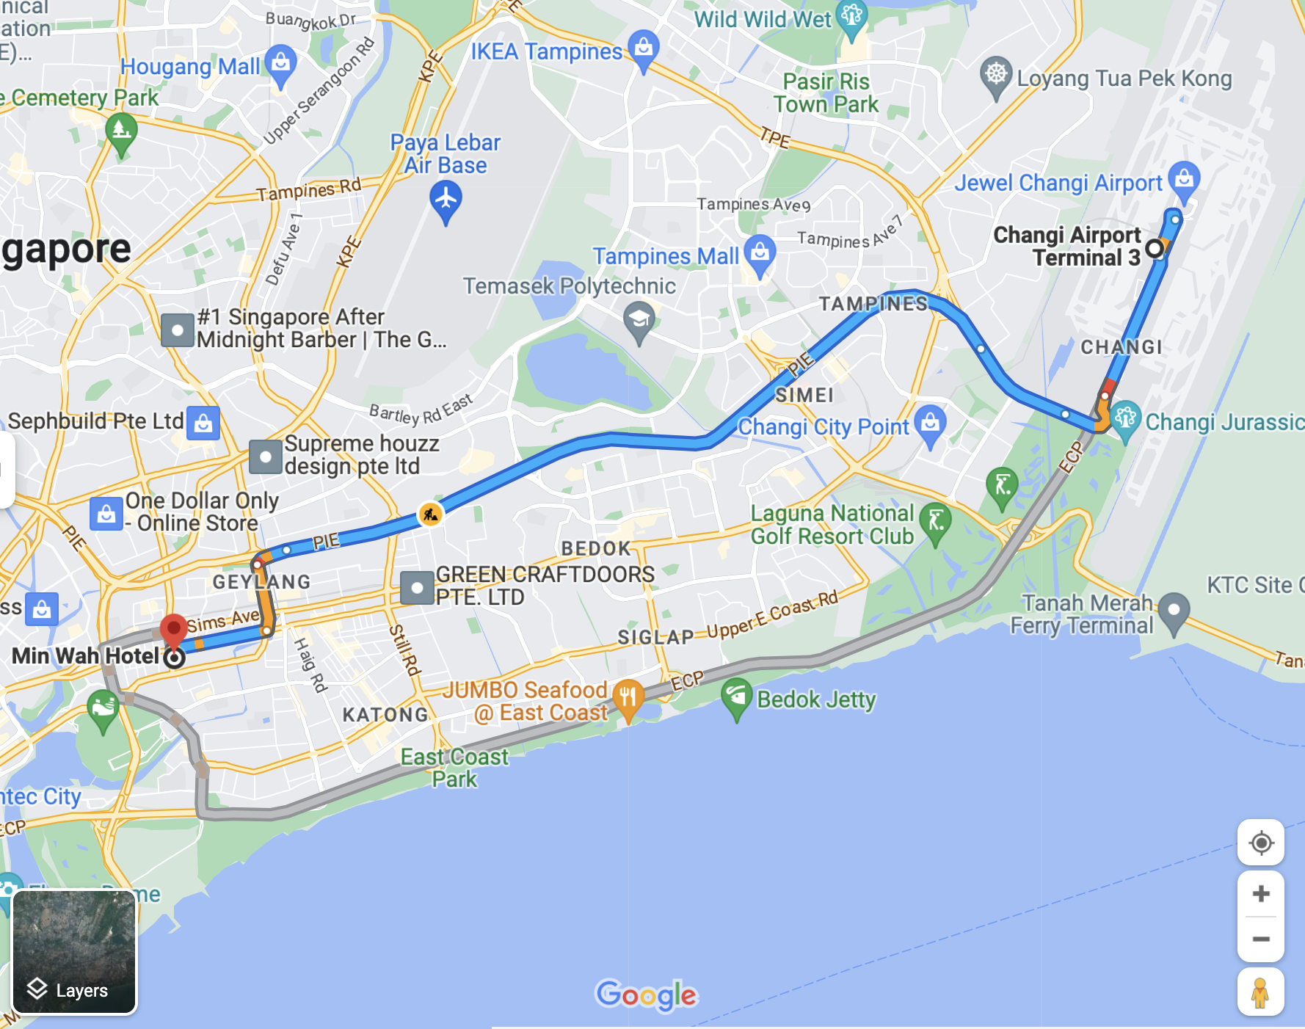

###### Google Maps Result for Table V.

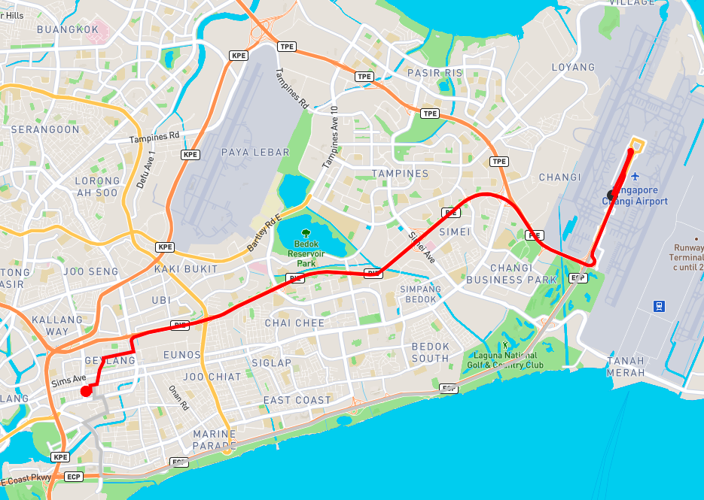

###### RouteSAV Result for Table V.

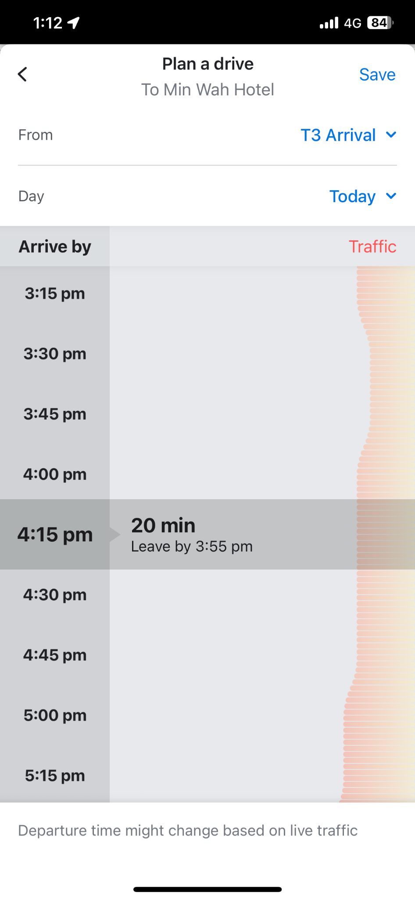

###### Waze Results for Table V.

1. Changi Airport Terminal 3 to Amrise Hotel

|  |  |  |  |
| --- | --- | --- | --- |
| Time Taken | Distance Taken | Cost | Fuel |
| Google Maps | | | |
| 20 min | 16.8 km | - | - |
| RouteSav | | | |
| 25 min | 17.58 km | $0.0 | 3.25 litres |
| Waze | | | |
| 21 mins | - | - | - |

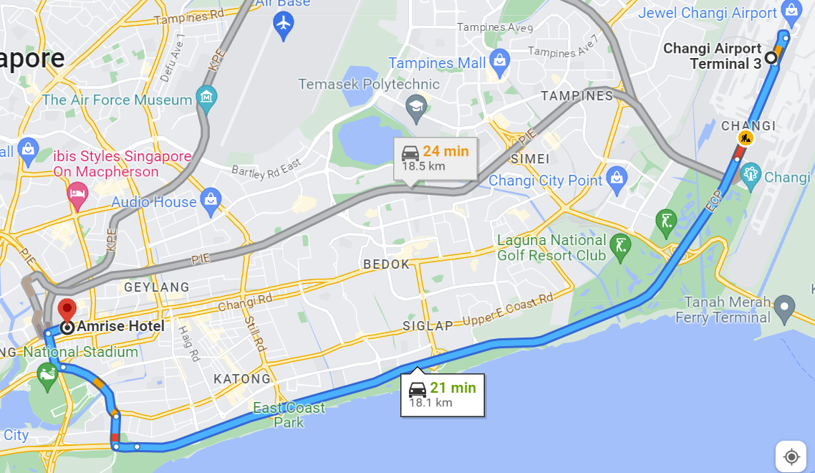

###### Google Maps Result for Table VI.

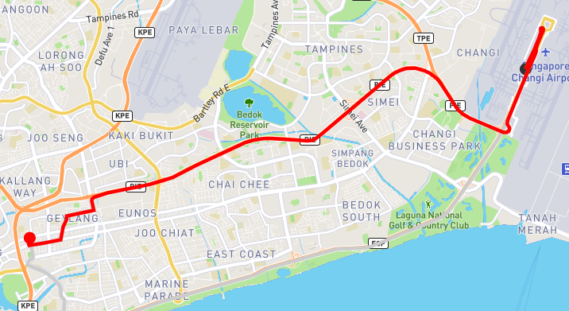

###### Google Maps Result for Table VI.

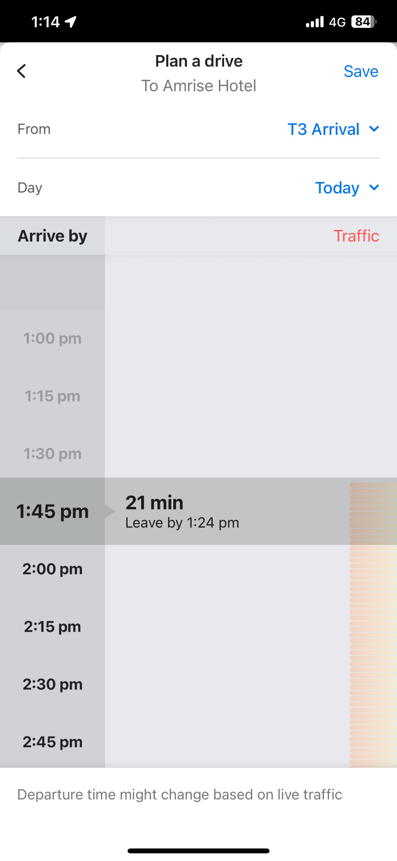

###### Waze Result for Table VI.

## D. Result Analysis

**Variation in Number of Nodes in OpenStreetMap (OSM) Data**

The difference in the number of nodes between RouteSav's OSM data and data used by commercial platforms such as Google Map contributes significantly to the disparate results. OSM is a crowdsourced platform, and the data may differ in completeness and accuracy compared to proprietary datasets used by major corporations. As a result, OSM may differ from Google Maps in terms of roads and, subsequently, the route suggestions and distance calculation.

**Impact of vehicle speed difference**

Another significant factor influencing the variation in results is the difference in speed between the bus and regular cars on commercial platforms. Buses usually have different characteristics from cars, including acceleration, deceleration, and top speeds. Due to this, the recommended routes may differ in travel times and distances depending on the type of vehicle used in the calculations.

The impact of these factors can be summarised by saying that while minor discrepancies exist, THye do not substantially detract from the RouteSav overall functionality. As a matter of fact, it stands out from Google and Wave due to its ability to integrate ERP charges.

**Transparent cost calculation through ERP integration**

RouteSav's seamless integration of ERP charges provides users with invaluable information about the tolls and fees associated with their chosen route. Having this level of transparency, particularly when it comes to the financial aspect of travel, enables users to make informed decisions. By providing users with real-time and accurate information about these costs, RouteSav helps users plan their routes by being aware of the cost which makes it an excellent tool for businesses and individuals.

**The amount of fuel consumed**

RouteSav stands out as a better option because it takes fuel consumption into account when recommending routes. It enables users to make more informed decisions when planning their journey. This is done by providing information on how much fuel a specific route is likely to consume. This feature is especially useful for those concerned about the environment or whether they want to reduce their fuel cost.

## E. Area of Improvement

**Mobile Application**

The addition of a mobile application version to RouteSav will not only provide users with more convenience but also greatly increase its user base. A mobile version is a reasonable next step to keep up with current trends in today's tech-savvy environment where mobile apps are essential to daily life. Due to the extensive usage of smartphones and tablets, a mobile app would probably be more well-liked by users, increasing platform engagement. Additionally, the mobile app's potential for location-based services and push alerts may add additional features and functionalities that will improve the navigation experience overall.

**Data Accuracy**

Although OSM data is retrieved every time the script is run, the accuracy of node and way data is not 100% accurate as OSM is a crowdsourced platform. The accuracy of data can vary due to contributions from volunteers in the OSM community. It may lack completeness and updates compared to datasets used by commercial platforms, such as Google Maps. We can diversify our data sources

**Real-Time GPS Location**

Modern navigation systems must have real-time GPS position. It provides precise device tracking using satellite signals, delivering real-time position data for navigation, ride-sharing, emergency services, fleet management, and logistics. Overall, this technology has transformed several industries, including navigation, and it is expected to continue to advance.

**Directions**

With the inclusion of directions into the application RouteSAV will help users when they are on their journey as they will be able to have the directions live while they are driving. This helps the users have more information to make a clearer decision while on the road. On top of that, this can also prevent accidents as users will have earlier notice on when they need to turn and filter lanes as soon as they know the direction to turn.

**Different Types of Vehicles**

In the future when onboarding more drivers that have different vehicle types and models, we will incorporate more Vehicle models and their specification to estimate the required fuel and how long it takes to travel from point A to point B. With this estimate, they will be able to know petrol use on

**Dynamic Source & Destinations**

By incorporating features like letting users select their source and destination, users have more control over their travel arrangements and are able to customise their itineraries for different objectives, discover new places, and reduce travel times based on personal preferences. RouteSav distinguishes itself as a dependable and user-centric navigation system by offering this level of user-driven customization, meeting a variety of travel demands with simplicity and ease. This feature will allow for business expansion by including more hotels as part of the service provided.

# Limitations

## Dataset

The dataset is not very accurate and does not have all the nodes plotted out from the source OpenStreetMap. This means that the route that will be generated by the algorithm might not be accurate. However, it is a good representation of how our algorithm works based on the nodes that we have currently.

# Conclusion

In conclusion, RouteSAV provides a seamless, cost-effective, and efficient experience for bus operators in Singapore. Leveraging on Dijkstra’s algorithm, real-time analysis, and data integration from multiple sources, the system optimises travel routes, minimises operating costs, and considers various factors such as fuel consumption, ERP charges, and traffic conditions. While RouteSAV has demonstrated promising results and benefits, continuous improvement, and refinement is important to address our limitations. By further improving it based on user feedback, adding more algorithms and using more accurate data, RouteSAV has the potential to revolutionise tourist bus transportation not only in Singapore but in other cities worldwide.

##### Acknowledgment

I would like to extend sincere thanks and respect to everyone who helped to make this project a success. I would like to express my sincere gratitude to my professors for all of their help, support, and assistance during the course of this project.

##### References

1. Centre for Liveable Cities, "Plan for Tourism," Singapore, 2015. [Online]. Available: https://www.clc.gov.sg/docs/default-source/urban-systems-studies/plan-for-tourism.pdf.[Accessed: May 26, 2023].
2. ganga4518, "The Algorithms Behind The Working Of Google Maps," 30 August 2021. [Online]. Available: https://blog.codechef.com/2021/08/30/the-algorithms-behind-the-working-of-google-maps-dijkstras-and-a-star-algorithm/#:~:text=A*%20algorithm%20is%20similar%20to,proves%20to%20be%20more%20proficient.
3. AxiomQ, "How Can Route Optimisation Save You 20% on Fuel Usage?," AxiomQ Blog. [Online]. Available: https://axiomq.com/blog/how-can-route-optimisation-save-you-20-on-fuel-usage/. [Accessed: May 26, 2023].
4. "ERP," One Motoring, Land Transport Authority of Singapore. [Online]. Available: https://onemotoring.lta.gov.sg/content/onemotoring/home/driving/ERP/ERP.html. [Accessed: May 26, 2023].
5. "Google Maps," Google. [Online]. Available: https://www.google.com/maps/about/#!/. [Accessed: May 26, 2023].
6. P. S. Pansambal, N. Lyer, V. Meherkar and P. Sharma, "Literature Review: Navigation Systems for Fastest Route," International Journal of Advanced Research in Computer and Communication Engineering, vol. 5, no. 3, 2016.
7. B. Popa, "Google Maps Under Fire for Incorrect Information, Outdated Imagert," autoevolution, 15 April 2021. [Online]. Available: https://www.autoevolution.com/news/google-maps-under-fire-for-incorrect-information-outdated-imagery-159357.html. [Accessed 20 July 2023].
8. M. Burris, M. Khan and J. Johnson, "Is That Route Really the Most Fuel-Efficient? [Policy Brief]," 1 Feburary 2023. [Online]. Available: https://rosap.ntl.bts.gov/view/dot/67950. [Accessed 20 July 2023].
9. "Waze Live Map," Waze. [Online]. Available: https://www.waze.com/live-map/. [Accessed: May 26, 2023].
10. F. Trapsilawati, T. Wijayanto and E. S. Jourdy, "Human-computer trust in navigation systems: Google maps vs Waze," Communication in Science and Technology, 2019.
11. S. Orgera, "What is Waze and How does it work?," Lifewire: Tech for Humans , 2 December 2020. [Online]. Available: https://www.lifewire.com/what-is-waze-4153570. [Accessed 20 July 2023].
12. B. Popa, "Key Waze Feature Returns as Part of "Gamification" Update," atuoevolution, 10 January 2022. [Online]. Available: https://www.autoevolution.com/news/key-waze-feature-returns-as-part-of-gamification-update-178770.html. [Accessed 20 July 2023].
13. Waze, "Under the Hood: Real-time ETA and How Waze Knows You’re on the Fastest Route," Medium, 28 August 2020. [Online]. Available: https://medium.com/waze/under-the-hood-real-time-eta-and-how-waze-knows-youre-on-the-fastest-route-78d63c158b90. [Accessed 20 July 2023].
14. “OneMap API,” GovTech Singapore. [Online] Available: https://www.developer.tech.gov.sg/products/categories/data-and-apis/onemap-apis/overview.html [Accessed: July 1 , 2023].
15. eCoachManager, "The unveiling of the New Scania Touring Coach," ecoachmanager, 18 January 2018. [Online]. Available: https://ecoachmanager.com/unveiling-new-scania-touring-coach/. [Accessed 30 June 2023 ].
16. J. Wong, "Speeding Fines in Singapore," The Singapore Lawyer, 22 June 2023. [Online]. Available: https://www.thesingaporelawyer.com/blog/speeding-fine/. [Accessed 23 June 2023 ].

##### Appendix

## Takeaways from Project

In the creation of our project, we made full use of a variety of data structures and algorithms to address the navigation issue and effectively optimise route computations. The learnt data structures, such as graphs and priority queues, were extremely important in properly managing real-time data and representing the road network.

We used a graph data structure to represent the road network, where each node represented a particular location or intersection and edges represented the road segments linking them. We were able to accurately simulate the linkages and interconnections between various sites thanks to this network structure.

We used graph search algorithms like Dijkstra's algorithm to calculate routes. We were able to determine the most effective path based on multiple factors thanks to Dijkstra's method, which found the shortest path between two points in a weighted graph.

## Personal Reflection

**Xande Koh Yong En**

Throughout the duration of this project, I have gained extensive experience and valuable insights in the realm of developing a maps application with a backend. Building this application has exposed me to numerous considerations that come into play, particularly in understanding the factors that impact travel time. The practical application of Dijkstra's algorithm in a real-life scenario has been a significant learning milestone, and I have successfully integrated it into our system. Furthermore, I have come to appreciate the critical role of optimising the algorithm to ensure efficient system performance.

Witnessing the theories learned in class come to life through this project has been immensely rewarding. Additionally, I discovered and utilised third-party libraries like osmnx for getting the updated nodes and plotly for mapping nodes and visualisation, enriching the application's functionalities.

While working on the project, our team encountered various challenges, including optimising the algorithm and devising ways to provide realistic estimated travel times by considering factors such as road conditions but overcame them as a team through many iterations of ideation and thinking of alternative ways.

Overall, collaborating with my team members has been a gratifying experience, and it allowed us to form strong bonds while applying the knowledge acquired in class to build a practical and functional application together. The project not only honed my technical skills but also emphasised the importance of teamwork and creative problem-solving. I am genuinely pleased with the outcome and the lessons learned during this enriching journey

**Nicholas Sng Ray Shiang**

Through this project, I got to experience and learn different path finding algorithms that I never knew. I learnt Dijkstra algorithm, A-star, breadth first search, and depth first search, even though we did not implement it. Throughout the project, we faced several obstacles and learned valuable lessons. One of the significant challenges was working with OSM data. We spent considerable time preprocessing the data, but accuracy of it impacted the reliability of our route calculations. Additionally, I learnt to use different libraries, such as OSM and plotly which will be very helpful in the future when learning to visualise data. It was very rewarding to overcome the obstacles and improve my understanding on different path finding algorithms and different libraries. In summary, this project was a very insightful and useful learning experience for me, and the module taught me very useful information that I will definitely use in the future.

**Kenneth Wang Yong Qi**

Through this project development, I have gained valuable insights and learning experience that have improved my understanding of this module. The use of directed graphs, and graph search algorithms like Dijkistra’s has been essential in optimising route calculations and providing precise navigation guidance. Additionally, this project has allowed me to witness the application of the concepts taught in the module and how they can help to create effective navigation solutions.

In addition, I learnt that effective communication and open discussion were among the key assets that contributed to our team's success. Regular team meetings allowed us to freely discuss problems, brainstorm ideas for solutions, and collectively address any issues that we encountered.

Overall, this project has been a valuable learning experience for me. I have gained valuable insights into effective teamwork, communication, this module and I am proud of what our team has accomplished together.

**Muhammad Fiqri Adam Bin**

Throughout this project, I've had the opportunity to delve into the fascinating world of geospatial analysis and optimisation. It all started with understanding the power of third-party libraries like osmnx, plotly, pytz, and requests, which opened up a world of possibilities in dealing with geographical data and real-time information.

It was exciting to investigate and implement Dijkstra's pathfinding algorithm as part of this project. It was both challenging and rewarding to learn graph theory and apply pathfinding algorithms to find the shortest route between two points on a map. Now I have more confidence in approaching optimization problems and finding efficient solutions.

Finally, this project has been a life-changing experience for me. I am grateful for the opportunity to work with my team, and I am proud of the results we achieved together. Lessons learned, skills gained, and friendships formed will undoubtedly shape my future endeavours as a developer.

**Goh Geok Ling**

Through this project, I got to understand how Dijkstra’s Algorithm is being used in map navigation after learning it during our lecture. It is really interesting to see how different metrics are being used to aid the route calculation to ensure that the route we have provided is the most efficient. The program has allowed me to learn about Python libraries that have helped us create our own applications. It was very fascinating to be able to do application testing as it allowed us to have a reality check. This has taught me the importance of having a user-centric design as important as the algorithm for our program.

It was a great experience to be able to work together as a team on this project as it allows me to learn from other teammates and improve myself from there. This has also taught me the importance of effective communication, to ensure that we are all on the same frequency for this project.

This project was a great opportunity to apply what we had learned in class to a real-life problem, while at the same time offering us the chance to explore and compare the various algorithms to see which is best for the application.

## Contributions

|  |  |  |
| --- | --- | --- |
| **Name** | **Student ID** | **Contribution** |
| Xande Koh Yong En | 2203203 | * Calculate total distance * Calculate total cost * Calculate fuel consumption * Function to choose the optimal route * Report * Slides * Video Demo |
| Nicholas Sng Ray Shiang | 2203197 | * Get and filter incident data from LTA * Add incident data to Dijkstra as a factor * Fix bugs * Report * Slides |
| Kenneth Wang Yong Qi | 2203193 | * Get and filter ERP data from LTA * Add ERP data to Dijkstra as a factor * Calculate estimated time * Optimised code * Report * Slides |
| Muhammad Fiqri Adam Bin | 2202878 | * Implemented dijkstra algorithm * Adding OSM data * Generate routes * Data preprocessing * Report * Slides * Video Demo & editing |
| Goh Geok Ling | 2202614 | * Created UI for the application * Plot map * Application Testing * Report * Slides * User Manual |